
SCHOOL OF COMPUTER SCIENCE AND IT DEPARTMENT OF CS & IT
BCA PROGRAMME
SPECIALIZATION : GENERAL

SUBJECT NAME : ANALYSIS AND DESIGN OF ALGORITHMS SUBJECT CODE : 23BCA4C01
SEMESTER IV
ACTIVITY 2
Smart City Power Grid Optimizer(KRUSKALS ALGORITHM)
Date of Submission :
15-04-2026
Submitted by :
RANJITH KUMAR – 24BCAR0487


CERTIFICATE
This is to certify that Mr/MS RANJITH KUMAR has satisfactorily completed activity prescribed by JAIN (Deemed to be University) for the 4th Semester degree course in the year 2026-2027 Mini Project with Real Time Applications on the topic Smart City Power Grid Optimizer for Activity – 2.

S.No | USN | Name Of The  Student | Problem statement  5 | Implementation of Real Time Application  5 | Demo & Viva  5 | Total Marks 15
1 | 24BCAR0487 | RANJITH KUMAR

Signature of the staff member
Dr.A.Kannagi

Introduction
In modern infrastructure planning, efficiently connecting multiple locations with minimal cost is a critical challenge. This problem can be modeled using graph theory, where each location is represented as a vertex and the possible connections between them are represented as edges with associated costs. The objective is to design a network that connects all locations while minimizing the total cost and avoiding redundant connections.
This program implements Kruskal’s Algorithm, a greedy approach used to find the Minimum Spanning Tree (MST) of a graph. The Minimum Spanning Tree ensures that all vertices (city zones) are connected with the least possible total edge cost and without forming cycles. This makes it highly suitable for real-world applications such as designing power grids, road networks, communication systems, and pipeline layouts.
In this implementation, each possible connection between zones is represented as a structure containing the source, destination, and cost. The algorithm begins by sorting all connections in increasing order of cost. It then iteratively selects the cheapest connection, ensuring that adding it does not form a cycle. Cycle detection is efficiently handled using the Union-Find (Disjoint Set) data structure with path compression and union by rank techniques.
The final output of the program displays the selected connections that form the optimal network along with the total minimum cost required to connect all zones. This demonstrates how greedy algorithms can be effectively applied to solve optimization problems in a practical and efficient manner.

Problem Definition
In many real-world scenarios such as power distribution, road construction, and communication networks, it is necessary to connect multiple locations (or zones) in the most cost-efficient way. Each pair of locations can be connected using a link (or cable), and each link has an associated cost.
The problem is to determine a set of connections that:
- Connects all the given locations (vertices)
- Minimizes the total cost of connections
- Avoids the formation of cycles (no redundant paths)
This can be modeled as a graph problem, where:
- Vertices represent city zones
- Edges represent possible connections between zones
- Weights represent the cost of each connection
The objective is to find a Minimum Spanning Tree (MST) of the graph.
To solve this problem, Kruskal’s Algorithm, a greedy approach, is used. The algorithm selects the lowest-cost edges first and ensures that no cycles are formed by using the Union-Find (Disjoint Set) data structure.
Thus, the problem focuses on designing an optimal network that connects all zones with the least possible cost while maintaining efficiency and simplicity in structure.

Objectives
The main objectives of this project are:
- To design an efficient method for connecting multiple city zones with minimum total cost.
- To apply Kruskal’s Algorithm, a greedy technique, to solve the Minimum Spanning Tree (MST) problem.
- To represent real-world network connections using a graph model (vertices and weighted edges).
- To ensure that all zones are connected without forming cycles, avoiding redundant connections.
- To implement the Union-Find (Disjoint Set) data structure for efficient cycle detection.
- To sort connections based on cost and select the most optimal ones step-by-step.
- To demonstrate how greedy algorithms can be used in real-life applications like power grids and network design.
- To compute and display the final optimal connections and total minimum cost.

Algorithm:
- Start

- Input the graph
  - List all vertices and edges with their costs

- Sort all edges
  - Arrange edges in increasing order of cost

- Initialize subsets
  - Create a separate set for each vertex
  - (Each vertex is its own parent initially)

- Set selected edges count = 0

- Repeat until MST is formed (V - 1 edges):
  - Pick the smallest edge from the sorted list
  - Find the parent (set) of both vertices using find()
  - If both vertices belong to different sets:
    - Include this edge in the MST
    - Perform union() to merge the sets
    - Increment selected edges count
  - Else:
    - Discard the edge (it forms a cycle)

- Display the selected edges

- Calculate total cost of MST

- Stop

Flowchart:

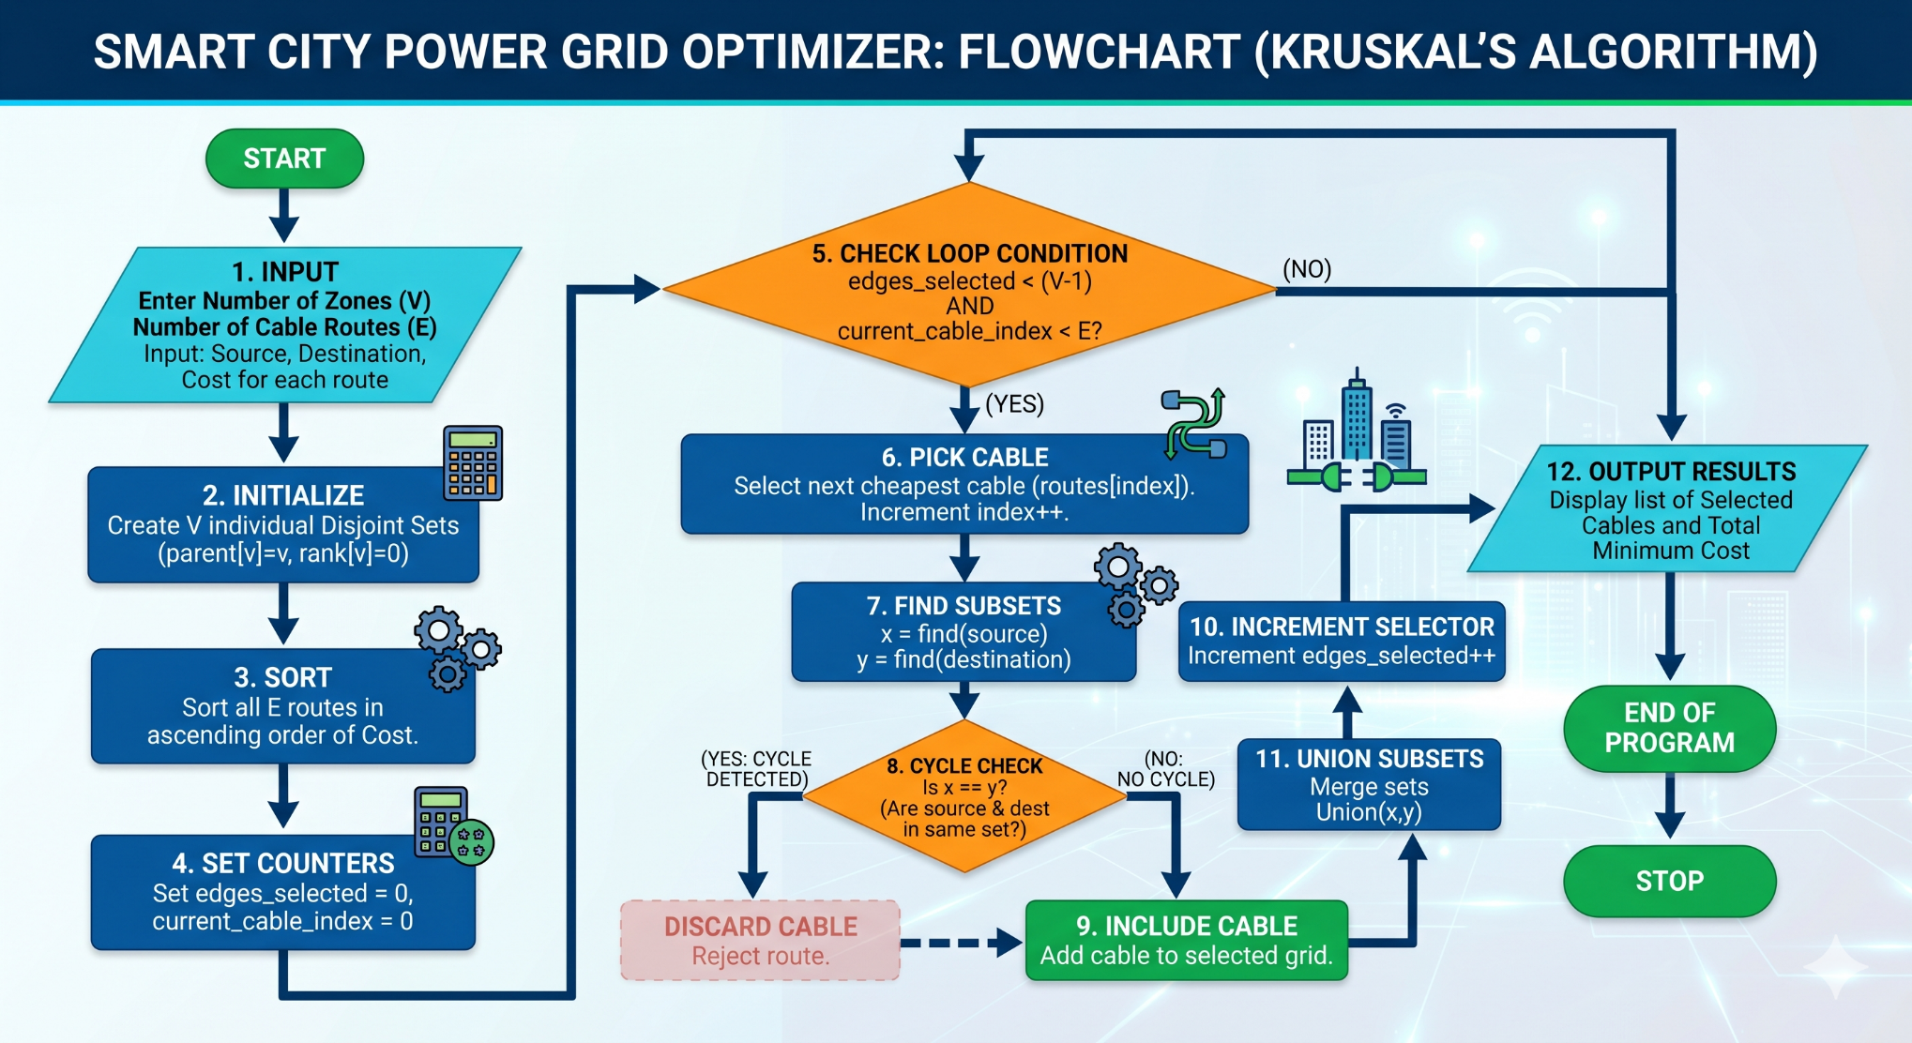
CODE:-
#include <stdio.h>
#include <stdlib.h>

// 1. Structure to represent a single cable connection
struct Cable {
int src, dest, cost;
};

// 2. Structure for the "Union-Find" technique (used to detect loops/cycles)
struct Subset {
int parent;
int rank;
};

// Helper function: Finds which set a zone belongs to
int find(struct Subset subsets[], int i) {
if (subsets[i].parent != i)
subsets[i].parent = find(subsets, subsets[i].parent);
return subsets[i].parent;
}

// Helper function: Joins two sets of zones together
void Union(struct Subset subsets[], int x, int y) {
int xroot = find(subsets, x);
int yroot = find(subsets, y);

if (subsets[xroot].rank < subsets[yroot].rank)
subsets[xroot].parent = yroot;
else if (subsets[xroot].rank > subsets[yroot].rank)
subsets[yroot].parent = xroot;
else {
subsets[yroot].parent = xroot;
subsets[xroot].rank++;
}
}

// Helper function used by C's built-in qsort() to sort cables by cheapest cost
int compareCables(const void* a, const void* b) {
struct Cable* a1 = (struct Cable*)a;
struct Cable* b1 = (struct Cable*)b;
return a1->cost > b1->cost;
}

// The Greedy Algorithm: Kruskal's
void build_efficient_grid(struct Cable cables[], int V, int E) {
struct Cable result[V]; // This array will store our final chosen cables
int edges_selected = 0;
int i = 0;

// STEP 1: Sort all possible connections from cheapest to most expensive
qsort(cables, E, sizeof(cables[0]), compareCables);

// Create subsets for loop detection
struct Subset* subsets = (struct Subset*)malloc(V * sizeof(struct Subset));
for (int v = 0; v < V; ++v) {
subsets[v].parent = v;
subsets[v].rank = 0;
}

// STEP 2: Pick the cheapest cables, ensuring we don't create a closed loop
while (edges_selected < V - 1 && i < E) {
struct Cable next_cable = cables[i++];

int x = find(subsets, next_cable.src);
int y = find(subsets, next_cable.dest);

// If connecting these two doesn't form a loop, add it to our grid!
if (x != y) {
result[edges_selected++] = next_cable;
Union(subsets, x, y);
}
}

// Print the final output
printf("\n--- Final Power Grid Connections ---\n");
int total_cost = 0;
for (i = 0; i < edges_selected; ++i) {
printf("Zone %d --connected to-- Zone %d (Cost: %dM)\n",
result[i].src, result[i].dest, result[i].cost);
total_cost += result[i].cost;
}
printf("Total Minimum Cost to connect all zones: %dM\n\n", total_cost);

free(subsets);
}

// --- RUNNING THE PROJECT ---
int main() {
int V = 5; // Number of city zones (0 to 4)
int E = 6; // Total number of possible cables we mapped out

// Adding all possible connections between zones with their costs (in millions)
struct Cable cables[] = {
{0, 1, 10},
{0, 2, 18},
{1, 2, 6},
{1, 4, 20},
{2, 3, 70},
{4, 3, 15}
};

// Run the algorithm
build_efficient_grid(cables, V, E);

return 0;
}

OUTPUT
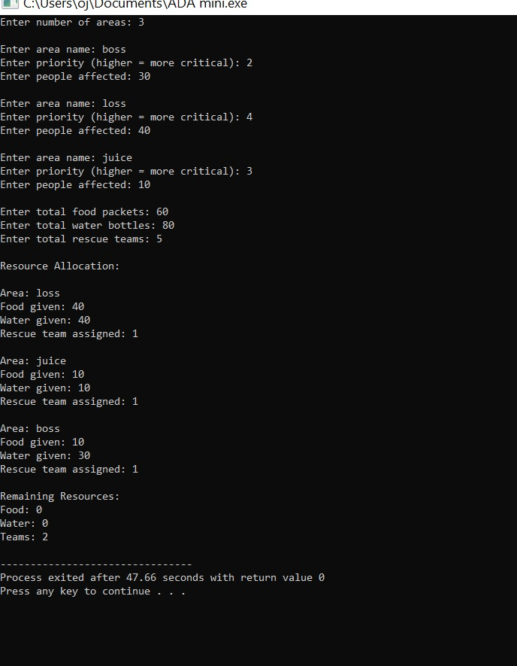

Step-by-Step Execution (Tracing)

Step-by-Step Execution Tracing

Input
Vertices (Zones): 0, 1, 2, 3, 4
Edges (with cost):
(0–1,10), (0–2,18), (1–2,6), (1–4,20), (2–3,70), (4–3,15)

Step 1: Sort Edges by Cost (Ascending)
(1–2,6), (0–1,10), (4–3,15), (0–2,18), (1–4,20), (2–3,70)

Step 2: Initialize Sets
Each vertex is its own set:
{0}, {1}, {2}, {3}, {4}

Step 3: Process Edges One by One
Step | Edge | Action | Reason | Sets After Step
1 | (1–2,6) | ✅ Selected | Different sets | {0}, {1,2}, {3}, {4}
2 | (0–1,10) | ✅ Selected | Different sets | {0,1,2}, {3}, {4}
3 | (4–3,15) | ✅ Selected | Different sets | {0,1,2}, {3,4}
4 | (0–2,18) | ❌ Skipped | Forms cycle | No change
5 | (1–4,20) | ✅ Selected | Different sets | {0,1,2,3,4}
6 | (2–3,70) | ❌ Skipped | Already connected | No change

Step 4: MST Completed
We stop when V - 1 = 4 edges are selected.

Final Selected Edges (MST)
(1–2,6)
(0–1,10)
(4–3,15)
(1–4,20)

Total Minimum Cost
6 + 10 + 15 + 20 = 51

Conclusion

This project successfully demonstrates the use of Kruskal’s Algorithm to solve the Minimum Spanning Tree (MST) problem in an efficient and practical manner. By representing city zones as vertices and possible connections as weighted edges, the problem of designing a cost-effective network was effectively modeled using graph theory.
The algorithm follows a greedy approach by selecting the smallest cost edges first while ensuring that no cycles are formed. The use of the Union-Find (Disjoint Set) data structure further improves efficiency by enabling fast cycle detection and union operations.
From the execution, it is observed that the algorithm produces an optimal set of connections that links all zones with the minimum total cost. This highlights the effectiveness of greedy techniques in solving optimization problems.
Overall, this implementation provides a clear understanding of how Kruskal’s Algorithm can be applied in real-world scenarios such as power grid design, transportation systems, and communication networks, ensuring both efficiency and cost minimization.

